Week 3 Assignment
Age Distributions
Based on the data information provided separately, generate a distribution by age. By distribution, basically, all you need to do is to get the count for the specified age range group.
For more information, you can see the handout for the project and the requirement below.
- Freeze the panes properly.
- You can set the printing to be on one page in a landscape layout.
- You cannot have any hard coded numbers in the distribution table. Even the age group under Age should be programmed.
- The highlighted cells are input cells.

Sheet name is “Age Distrib”.
Sheet “EeData” provided shall be used to complete some assignments below. Please keep in mind that the actual number of records might be much more than the records on the provided database, which your models must take into consideration. The meanings of prior year and current year status codes used on Sheet “EeData” are given below:
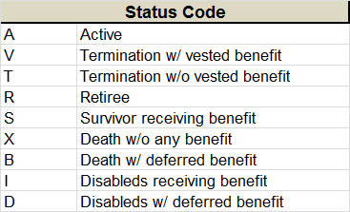
The Excel image for part of the model is shown below. The yellow highlighted area represents the input area. The model should work whether users enter inputs only in a part of area without gap or in the whole area.

